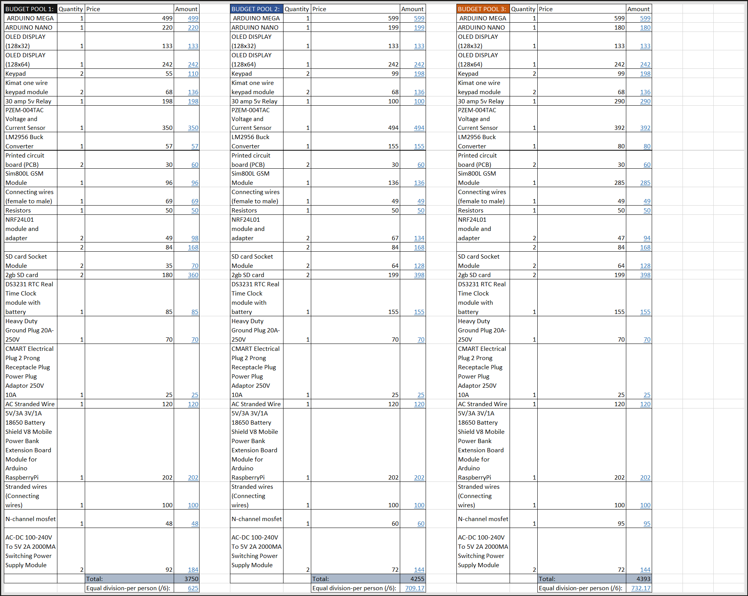Budget Plan for Purchasing of Components 1.1

Saturday, 7 August 2021

8:10 pm

